CS 255 System Design Document Template

This template lays out all the different sections that you need to complete for Project Two. Each section has guidance to prompt your thinking. You will need to continually reference the interview transcript as you work to make sure that you are addressing your client’s needs. There is no required length for the final document. Instead the goal is to complete each section based on what your client’s needs are. Remove this note when you are finished, and replace all bracketed text with the relevant information.

UML Diagrams

UML Use Case Diagram
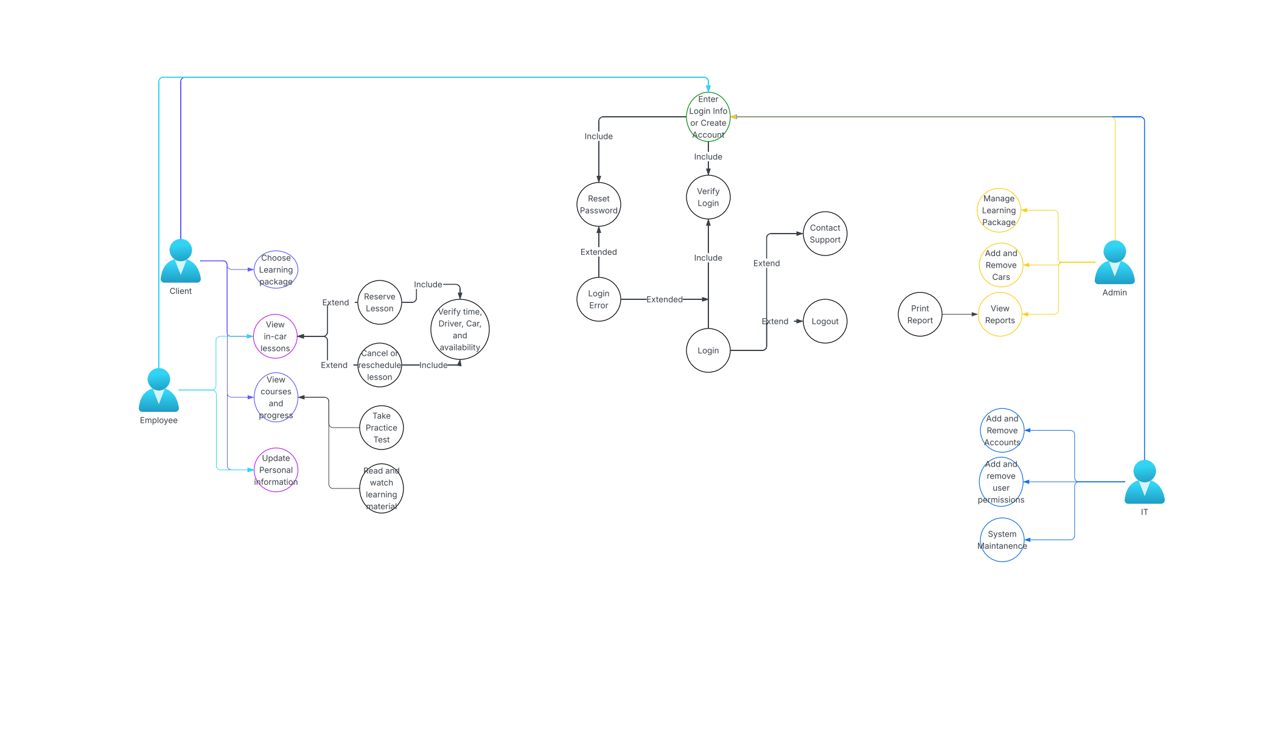

UML Activity Diagrams
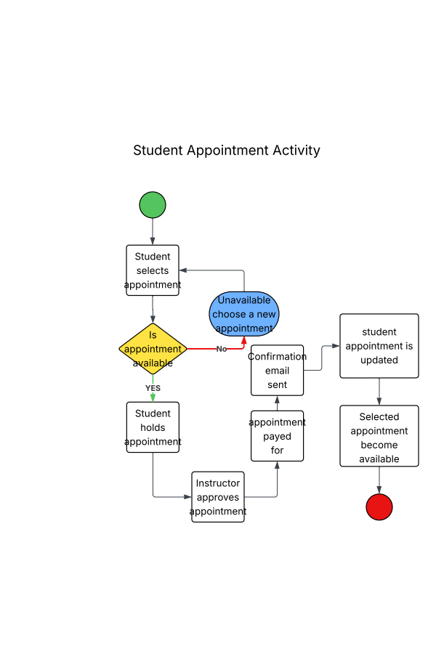
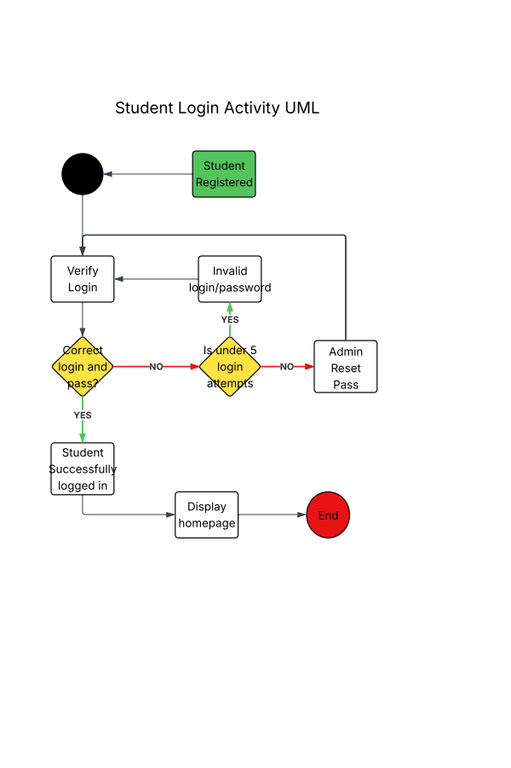

UML Sequence Diagram
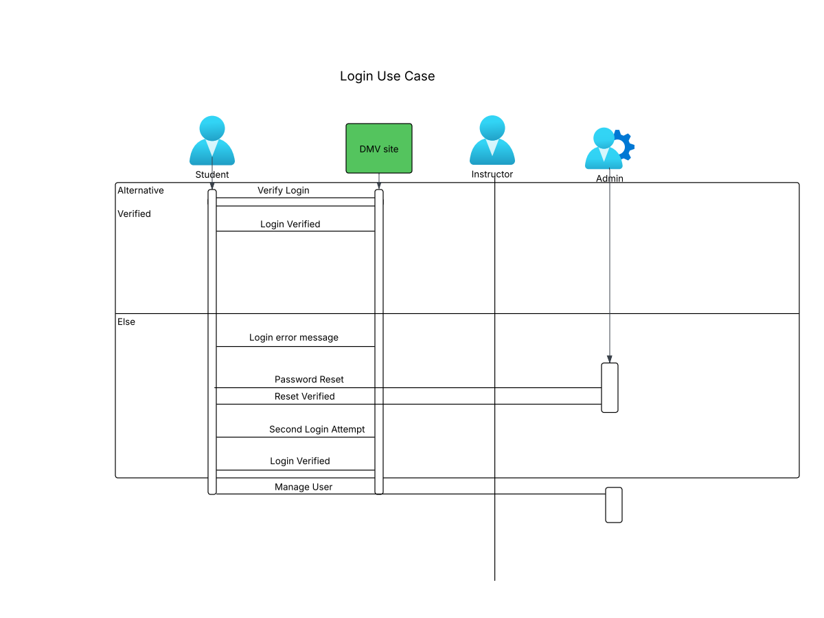

UML Class Diagram

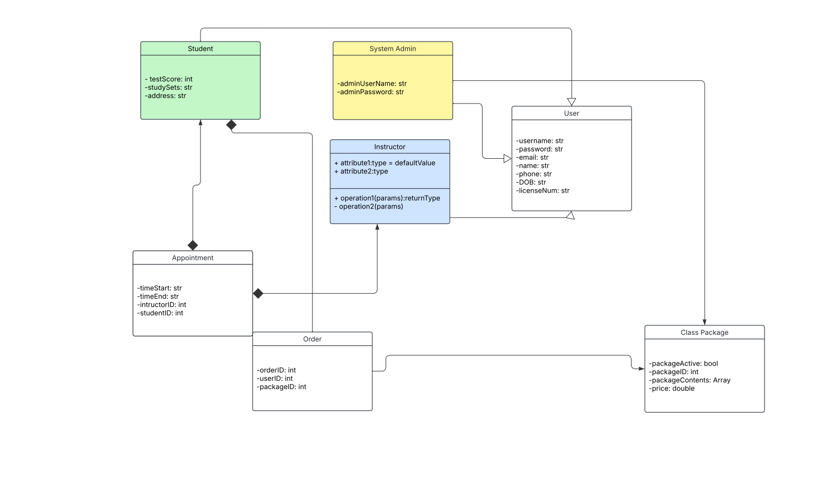

Technical Requirements
In terms of hardware, we will require a server to be built. We ill also need other components such as: computers, keyboards mouses and monitors so that we can interact with the system. We will require power and internet. Clients will require some kind of PC along with internet and power.

The software we will require would include some kind of OS. My recommendation is linux for security reasons and it`s lightweight nature. And the drivers pass software. We should also include security software.

We should create checks within the system to validate our transmissions to and from the client. We require an online payment system to be integrated.

